HDFS Commands

This document will help you understand the basic Hadoop commands, using which you can perform different operations on hdfs.

Note: Please do not copy paste the commands, instead type them manually on the terminal.

Command to find the Version of Hadoop:

Command: hadoop version

LS command:

Displays List of Files and Directories in HDFS file Path

Command: hadoop dfs –ls /

MKDIR command:

It creates the directory in HDFS
Syntax: sudo -u hdfs hadoop fs -mkdir /user/myfile
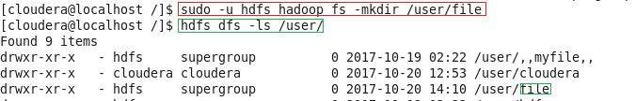

DU command:

Displays the summary of file lengths.

Syntax: hdfs dfs –du –s /path/to/file_in_hdfs

Command: hdfs dfs –du –s /user/cloudera/Technogeeks/test

Note: Here test is a file that exists in HDFS in the directory Technogeeks

TOUCHZ command:
Create a file in HDFS with file size 0 bytes

Syntax: hdfs dfs -touchz /directory/filename

E.g: hdfs dfs -touchz /user/cloudera/Technogeeks/sample.

Note: Here we are trying to create a file named "sample" in the directory 'Technogeeks' of hdfs with file size 0 bytes.

Use the du command to check the file size

Command: hdfs hdfs dfs -touchz /user/cloudera/Technogeeks/sample
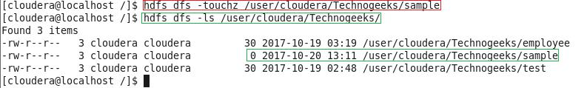

CAT command:

Copies source paths to stdout.

Syntax: hdfs dfs -cat /path/to/file_in_hdfs

Command: hdfs dfs -cat /user/cloudera/Technogeeks/test

Note: Here test is a file that exists in HDFS in the directory Technogeeks

TEXT command:

Takes a source file and outputs the file in text format.( Same as Cat command )

Syntax: hdfs dfs -text /path/to/file_in_hdfs

Command: hdfs dfs -text /user/cloudera/Technogeeks/test

Note: Here test is a file that exists in HDFS in the directory Technogeeks

copyFromLocal command :

Copy the file from Local file system to HDFS. Syntax: hdfs dfs -copyFromLocal <localsrc> URI

E.g: hdfs dfs -copyFromLocal /home/cloudera/Desktop/employee /user/cloudera/Technogeeks

Note: Here employee is the file present in the local directory - /home/cloudera/Desktop

copyToLocal command :

Copy the file from HDFS to Local File System.

Syntax: hdfs fs -copyToLocal URI <localdst>

Command: hdfs dfs -copyToLocal /user/cloudera/Technogeeks/test /home/cloudera/

Note: Here employee is a file present in Technogeeks directory of HDFS
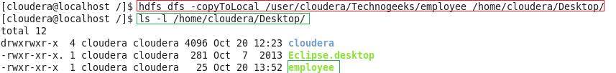

PUT command:

Copy single source, or multiple srcs from local file system to the destination file system. Syntax: hdfs fs -put <localsrc> ... <dst>

Command: hadoop fs -put /home/cloudera/Desktop/employee/ /user/cloudera/
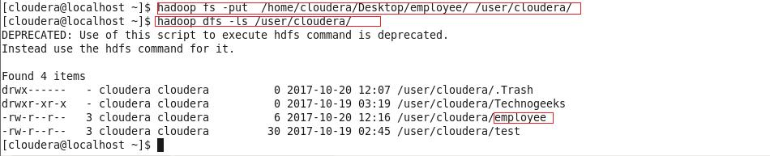

Note: copyFromLocal is similar to put command, except that the source is restricted to

a local file reference

GET command:

Copy files from hdfs to the local file system.

Syntax: hadoop fs -get filename <src> <localdst>

E.g: hadoop fs -get employee /user/cloudera/ /home/cloudera/

Note: copyToLocal is similar to get command, except that the destination is restricted to a local file reference

COUNT command:

Count the number of directories, files and bytes under the paths that match the specified file pattern. Command: hadoop dfs -count /user/cloudera/
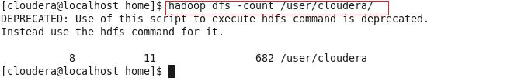

RM command:

Remove the file from HDFS.

Syntax: hdfs dfs –rm /path/to/file_in_hdfs

Command: hdfs dfs -rm /user/cloudera/test/
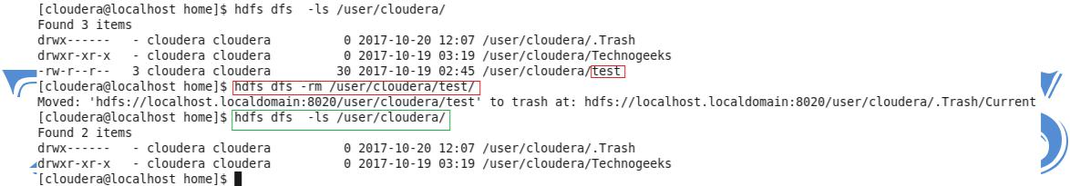

RMR command:

Remove the directory to HDFS

Syntax: hdfs dfs –rmr /path/to/directory_in_hdfs

Command: hdfs dfs -rmr /user/cloudera/myfile
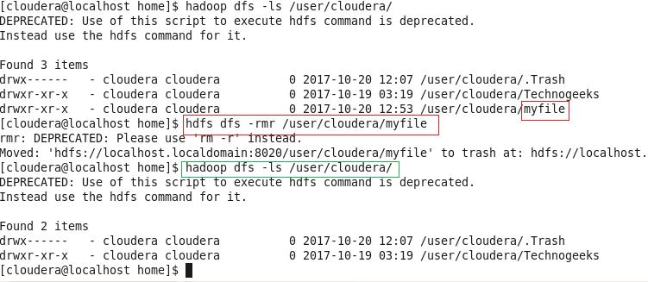

www.technogeeksCS.com | +918600998107

